Sector LA/LB and ISC San Pedro Chiefs invite you to the…

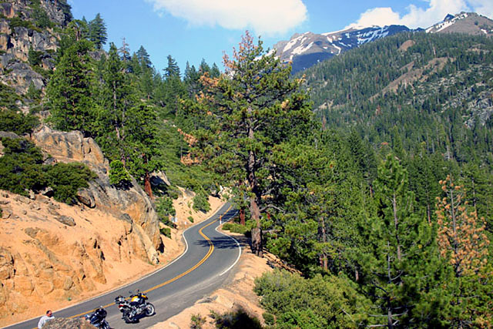
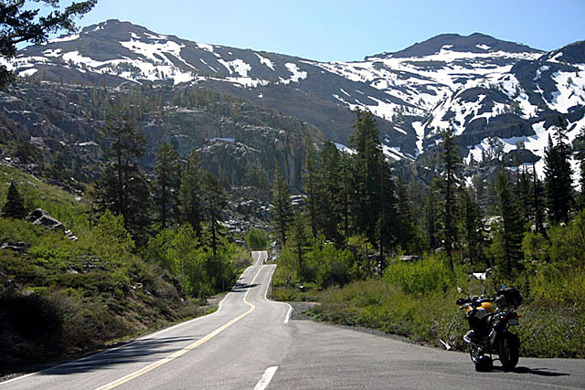
Escape The Basin Motorcycle Run!
Sponsored by the CPOA - Long Beach Chapter
Open to CG Members

Four days of eastern CA’S best scenery!
September 4th – 8th

Destination - Bridgeport, CA

Proceeds to benefit the Sunshine Foundation
Register here by midnight Friday, August 25.

GOT STAMINA?
Miles to Bridgeport from:

Alameda - 214
San Francisco – 227
Riverside – 347
Long Beach – 379
Oxnard – 380
San Diego – 443

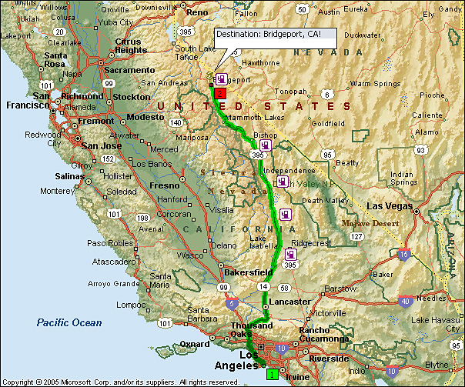

What’s the plan?
Ride to Bridgeport Monday, explore the area for a couple days and return Thursday. CMC Stevenson and BMC Smith are organizing this, but you choose a pace with friends based on your skill level for the recommended rides.

- Look over recommended rides provided with this flyer.
- Tuesday & Wednesday group rides start in the parking lot of the Hays Street Café. View map. Show up by 0900, choose ride partners, a route and go!
- Meet at Virginia Creek Settlement at sundown and swap ride tales from the day.

- The Rides -


1) Bridgeport/Sonora Run – 192 miles roundtrip

Spirited riding! The first 12 miles, route 395, is wide open with sweeps. Route 108 over the Sierra Nevada range and Sonora Mountains is an intense mix of straights and twisty sections with some very tight turns. There are many places to stop. Gas up at Mi-Wuk Village & Sonora. Get lunch at Strawberry or Sonora. - Check conditions.

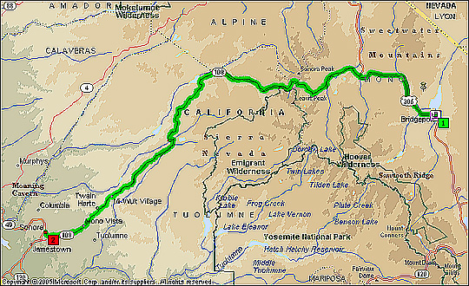

2) Bridgeport/Lake Tahoe Run - 176 miles roundtrip

Cruisers & posers favorite! Flat, with sweeps. Gas up at Topaz Lake. Get lunch at Stateline or S. Lake Tahoe. Continue on 395 to Reno if you have the time!

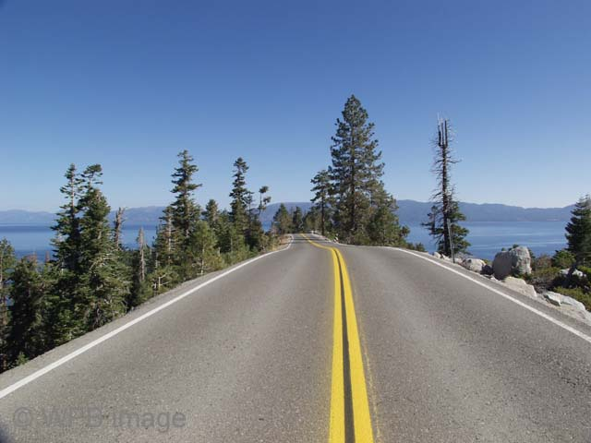
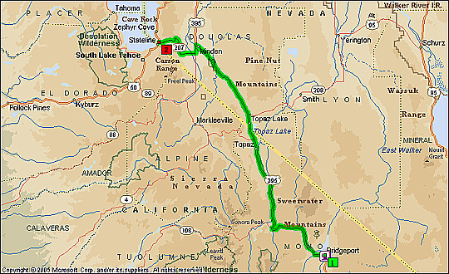

3) Bridgeport/Benton Loop - 233 miles

All bikes! Routes 167 and 359 have little traffic. Route 95 is flat with sweeps. Route 360 is…? Route 6 runs through Nevada moonscape into a deep green valley while re-entering CA. Route 120 snakes through tall pines and crisp mountain air. The last leg makes the entire loop worthwhile! Check conditions. Get gas at Hawthorne & Benton. Get lunch at Benton or bring snacks.

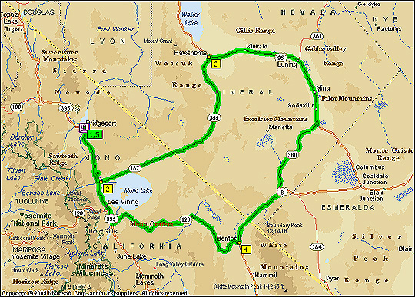

4) Short Hops from Bridgeport

Explore Bodie Ghost Town

Visit Yosemite National Park

- FAQS -

Who can register?
Coast Guard active duty, reserve, retired and auxiliary members are welcome.

I am new to motorcycling.
Some roads may be too challenging for new riders. If you are not sure about a route, do not start it.

What if it rains?
Have rain gear.

What if I get a flat tire?
Have a patch kit, air and know how to use them.

What if I wreck?
Have adequate insurance and an emergency contact number in your pocket. Do not ride alone.

Gas?
There are two gas stations in Bridgeport. Heads up: The Bridgeport-to-Sonora run is 98 miles one way with no refueling until you reach the outskirts of Sonora. Plan well. Know your bike’s limitations.

Food?
Bridgeport restaurants offer breakfast, burgers and dinners. Pack snacks for full days on the road or bring enough cash to eat out.

Lodging?
We recommend:

- Redwood Motel – In town.
- Silver Maple Inn – In town.
- Virginia Creek Settlement – Affordable cabins five miles south of Bridgeport. Some sleep 4! Book early and grab a group rate! Single rooms and tent sites also available. Breakfast available.
- More lodging options.

Anything else?

- Cell coverage does not exist in many areas. Avoid riding alone.
- Temperatures can vary greatly. Layered clothing works. Carry bottled water.
- Fill your tank every morning before gathering for a ride.
- Riders following or taking part in a group should expect to keep a spirited pace.

Register here by Friday, August 25.

Registration fees benefit the Sunshine Foundation; the original wish-granting organization for children. CMC Stevenson will accept cash or check Thursday, Sep 8th @ 0900 in the parking lot of the Hays Street Cafe, Bridgeport.

